UNIT 2:
Drugs Education
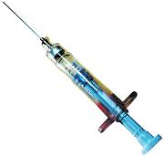

Name…………………………………………
Form…………………………………………...
Teacher………………………………………

Assessment Criteria for Drugs Education Unit 2:

Learning outcomes  The Learner will: | Assessment Criteria  The Learner can:
1. Know how to interpret information relating to recommended alcohol intake limits | 1.1 Explain what is meant by “percentage by volume” of an alcoholic drink  1.2 Research information on ten commonly available alcoholic drinks and use it to produce a report in tabular form which demonstrates the link between percentage by volume and units of alcohol  1.3 Describe current government guidance for men and women on recommended limits of alcohol consumption
2. Understand problems associated with alcohol abuse | 2.1 Describe at least three specific health risks associated with alcohol abuse  2.2 Produce a report describing at least three social  problems associated with alcohol abuse and making  recommendations for addressing them
3. Understand problems associated with tobacco use | 3.1 Name three main harmful substances in tobacco and describe the effect of each on the human body  3.2 Produce a report describing at least three social issues  associated with tobacco use, including passive smoking,  and making recommendations for addressing them
4. Know the dangers of the misuse of legal drugs | 4.1 Produce a report describing the potential effects of the  misuse of at least three legal drugs, e.g. valium, steroids
5. Know about the classification system for illegal drugs and how different drugs are classified | 5.1 Classify at least five illegal drugs into classes A, B and C
6. Know health risks associated with the use of illegal drugs | 6.1 Research and describe the health risks associated with the use of at least five illegal drugs
7. Know how the law is applied in respect of the possession and supply of illegal drugs | 7.1 Describe the possible penalties associated with the possession and supply of illegal drugs from each class (A, B and C)

Teacher Feedback Form

Assessment Criteria | Complete | Comments
1.1
1.2
1.3
2.1
2.2
3.1
3.2
4.1
5.1
6.1
7.1

Alcohol

Outcome 1.1: Explain what is meant by “percentage by volume” of an alcoholic drink.

_______________________________________________________________________________________________________________________________________________________________________________________________________________________________________________________________________________________________________________________________________________________________________________________

Outcome 1.2 Research information on ten commonly available alcoholic drinks and use it to produce a report in tabular form which demonstrates the link between percentage by volume and units of alcohol

Drink | Volume in mls | %BV | Working Out (Vol. x %BV ÷ 1000) | Alcohol Units Drunk

1.3 Describe current government guidance for men and women on recommended limits of alcohol consumption

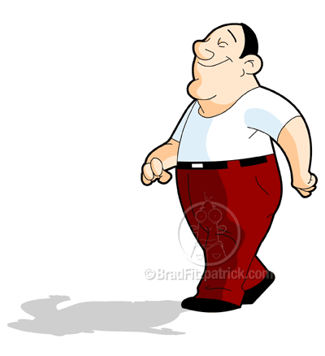
UNITS PER DAY
UNITS PER WEEK

UNITS PER DAY
UNITS PER WEEK

_________________________________________________________________________________________________________________________________________________________________________________________________________________________________

What is binge drinking?

Binge drinking means drinking more than twice the daily recommended maximum intake (i.e. for men, more than 8 units and for women, more than 6 units.)

_________________________________________________________________________________________________________________________________________________________________________________________________________________________________
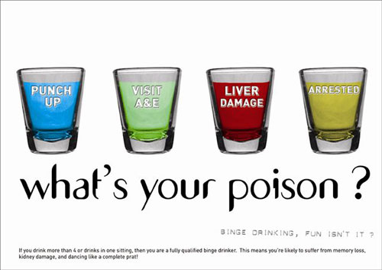

2.1 Describe at least three specific health risks associated with alcohol abuse

- ______________________________________________________________________________________________________________________________________________________________________________________________________________________________________________________________________________________________________________________________________________________________________________________________________________________________________________________________________________________________________________________________________________________________________________________________

- ______________________________________________________________________________________________________________________________________________________________________________________________________________________________________________________________________________________________________________________________________________________________________________________________________________________________________________________________________________________________________________________________________________________________________________________________

- ______________________________________________________________________________________________________________________________________________________________________________________________________________________________________________________________________________________________________________________________________________________________________________________________________________________________________________________________________________________________________________________________________________________________________________________________

2.2 Produce a report describing at least three social problems associated with alcohol abuse and making recommendations for addressing them

______________________________________________________________________________________________________________________________________________________________________________________________________________________________________________________________________________________________________________________________________________________________________________________________________________________________________________________________________________________________________________________________________________________________________________________________
______________________________________________________________________________________________________________________________________________________________________________________________________________________________________________________________________________________________________________________________________________________________________________________________________________________________________________________________________________________________________________________________________________________________________________________________
___________________________________________________________________________

______________________________________________________________________________________________________________________________________________________________________________________________________________________________________________________________________________________________________________________________________________________________________________________________________________________________________________________________________________________________________________________________________________________________________________________________
______________________________________________________________________________________________________________________________________________________________________________________________________________________________________________________________________________________________________________________________________________________________________________________________________________________________________________________________________________________________________________________________________________________________________________________________
___________________________________________________________________________
______________________________________________________________________________________________________________________________________________________________________________________________________________________________________________________________________________________________________________________________________________________________________________________________________________________________________________________________________________________________________________________________________________________________________________________________
________________________________________________________________________________________________________________________________________________________________________________________________________________________________________________________________________________________________________________________________________________________________________________________________________________________________________________________________________________________________________________________________________________________________________________________________________________________________________________________________________________

  - Name three main harmful substances in tobacco and describe the effect of each on the human body

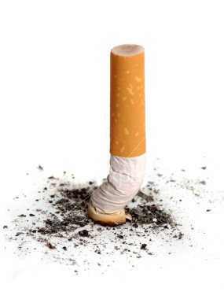

Three harmful substances found in a cigarette are:

- __________________________________
- __________________________________
- __________________________________

Substance | Part of Body | Description of Effects
3.2 Produce a report describing at least three social issues associated with tobacco use, including passive smoking, and making recommendations for addressing them

______________________________________________________________________________________________________________________________________________________________________________________________________________________________________________________________________________________________________________________________________________________________________________________________________________________________________________________________________________________________________________________________________________________________________________________________
________________________________________________________________________________________________________________________________________________________________________________________________________________________________________________________________________________________________________________________________________________________________________________________________________________________________________________________________________________________________________________________________________________________________________________________________________________________________________________________________________________
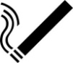

______________________________________________________________________________________________________________________________________________________________________________________________________________________________________________________________________________________________________________________________________________________________________________________________________________________________________________________________________________________________________________________________________________________________________________________________
________________________________________________________________________________________________________________________________________________________________________________________________________________________________________________________________________________________________________________________________________________________________________________________________________________________________________________________________________________________________________________________________________________________________________________________________________________________________________________________________________________

______________________________________________________________________________________________________________________________________________________________________________________________________________________________________________________________________________________________________________________________________________________________________________________________________________________________________________________________________________________________________________________________________________________________________________________________
________________________________________________________________________________________________________________________________________________________________________________________________________________________________________________________________________________________________________________________________________________________________________________________________________________________________________________________________________________________________________________________________________________________________________________________________________________________________________________________________________________

4.1 Produce a report describing the potential effects of the misuse of at least three legal drugs, e.g. valium, steroids

______________________________________________________________________________________________________________________________________________________________________________________________________________________________________________________________________________________________________________________________________________________________________________________________________________________________________________________________________________________________________________________________________________________________________________________________
________________________________________________________________________________________________________________________________________________________________________________________________________________________________________________________________________________________________________________________________________________________________________________________________________________________________________________________________________________________________________________________________________________________________________________________________________________________________________________________________________________
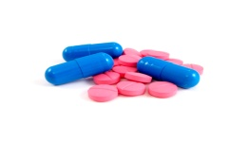

______________________________________________________________________________________________________________________________________________________________________________________________________________________________________________________________________________________________________________________________________________________________________________________________________________________________________________________________________________________________________________________________________________________________________________________________
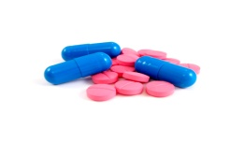
________________________________________________________________________________________________________________________________________________________________________________________________________________________________________________________________________________________________________________________________________________________________________________________________________________________________________________________________________________________________________________________________________________________________________________________________________________________________________________________________________________

______________________________________________________________________________________________________________________________________________________________________________________________________________________________________________________________________________________________________________________________________________________________________________________________________________________________________________________________________________________________________________________________________________________________________________________________
________________________________________________________________________________________________________________________________________________________________________________________________________________________________________________________________________________________________________________________________________________________________________________________________________________________________________________________________________________________________________________________________________________________________________________________________________________________________________________________________________________

.1 Classify at least five illegal drugs into classes A, B and C

Class A | Class B | Class C

6. Know health risks associated with the use of illegal drugs

6.1 Research and describe the health risks associated with the use of at least five illegal drugs

____________________________________________________________________________________________________________________________________________________________________
______________________________________________________________________________________________________________________________________________________________________________________________________________________________________________________________________________________________________________________________________________________________________________________________________________________________________________________________________________________________________________________________________________________________________________________________

____________________________________________________________________________________________________________________________________________________________________
______________________________________________________________________________________________________________________________________________________________________________________________________________________________________________________________________________________________________________________________________________________________________________________________________________________________________________________________________________________________________________________________________________________________________________________________

____________________________________________________________________________________________________________________________________________________________________
______________________________________________________________________________________________________________________________________________________________________________________________________________________________________________________________________________________________________________________________________________________________________________________________________________________________________________________________________________________________________________________________________________________________________________________________

____________________________________________________________________________________________________________________________________________________________________
______________________________________________________________________________________________________________________________________________________________________________________________________________________________________________________________________________________________________________________________________________________________________________________________________________________________________________________________________________________________________________________________________________________________________________________________

____________________________________________________________________________________________________________________________________________________________________
______________________________________________________________________________________________________________________________________________________________________________________________________________________________________________________________________________________________________________________________________________________________________________________________________________________________________________________________________________________________________________________________________________________________________________________________

7.1 Describe the possible penalties associated with the possession and supply of illegal drugs from each class (A, B and C)

 | Class A | Class B | Class C
Possession
Supply

